


EACTS Adult Cardiac Database
Quality Improvement Programme
User Sign-up Guide
Version 1.0
30th July 2025

ACD Overview and Objectives
The European Association for Cardio-Thoracic Surgery (EACTS) Adult Cardiac Database (ACD) is a collaborative registry and benchmarking tool of cardiac surgical data for centres on an international scale, giving surgical teams the advanced data tools and insights to continually improve outcomes for patients.
The ACD aims to:
- Bring participating hospitals, national registries and surgeons together to advance the field of cardiothoracic surgery through comparative data analysis and sharing of best practice.

- Support surgical training and education and informing evidence-based practices for current and future cardiothoracic surgeons.
- Provide a controlled access mechanism for researchers to request access to the data, regulated by a scientific committee and in line with established governance frameworks.

User Sign Up

ACD Registration form
Users that are EACTS Members or from an Individual Centre or National Registry that contributes data (Institutions) to the ACD are eligible to sign-up for the ACD and gain access to the ACD Web Platform.
ACD data onboarding for Institutions is officially completed through the ACD registration form which must be signed by the chief surgeon of an individual centre or a representative from a national society or registry. If you are interested in enrolling, please get in touch by emailing quip@eacts.co.uk

For EACTS Members
EACTS members should sign-up for the ACD using the email address that is entered in the EACTS membership system. This is typically the email EACTS will contact members on.

For Institutional users
Users who work at Individual Centres that have contributed data to the ACD, should sign up using their individual centre email address set-up by the centre’s Chief Surgeon.
ACD Founding Charter
The ACD Founding Charter establishes the governance framework for the ACD, outlining the terms of the agreement between EACTS and participants hospitals. It outlines the database's purpose of collecting anonymised cardiothoracic surgical data for quality improvement, benchmarking, and scientific research. It also includes information about General data Protection Regulation (GDPR) compliance.

Authentication
Users need to have downloaded and set-up the Microsoft authenticator application for the Sign-up process to be successful.

To access the ACD web platform please visit:
https://acd.eacts.org/

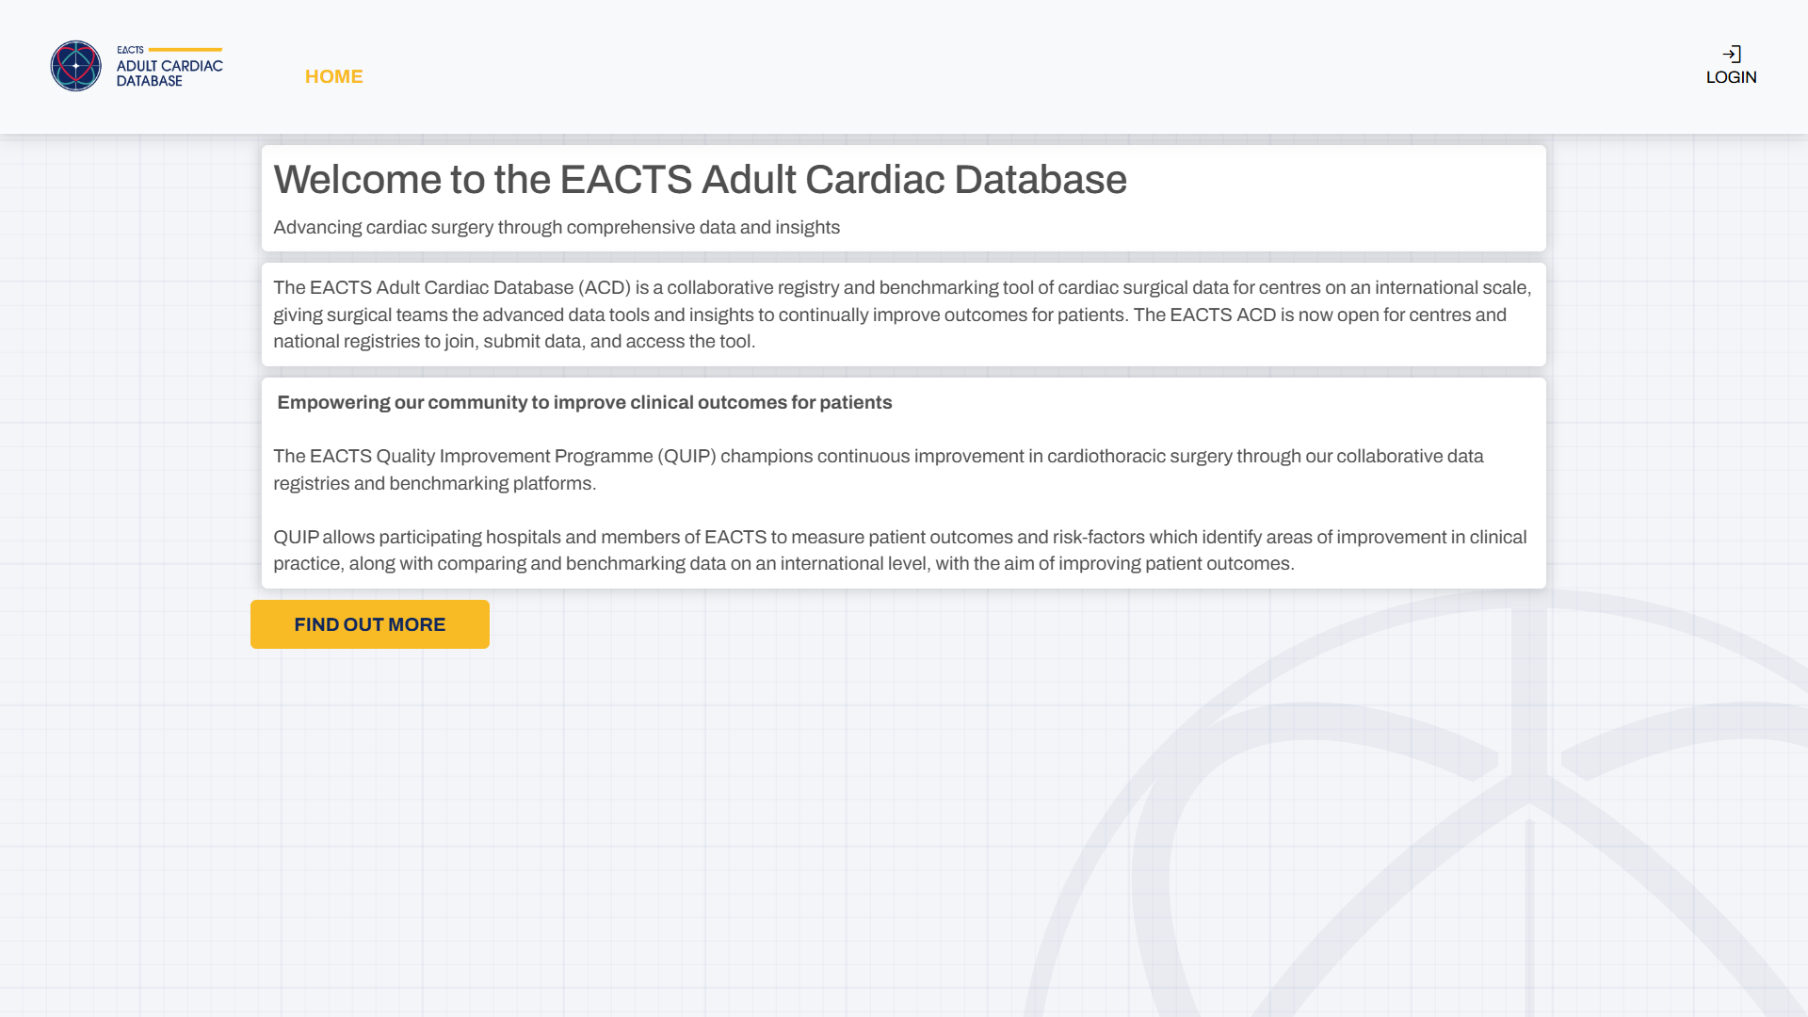
First time users will be taken to the ACD HOME page:

To login to the platform Select LOGIN

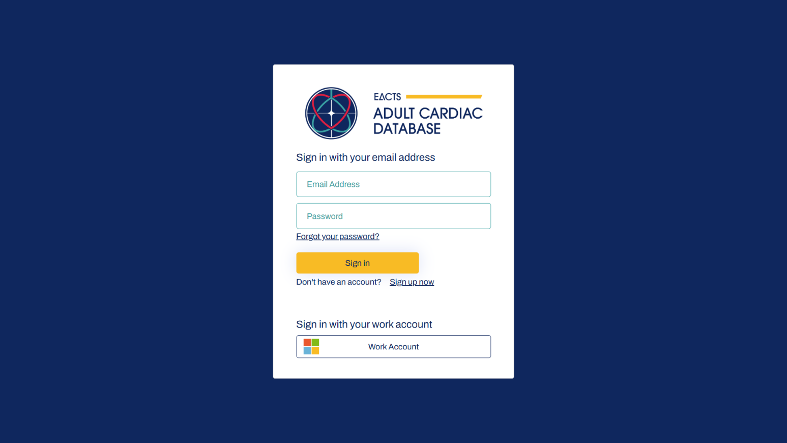
Users can sign-up for an account via two methods:
a) Users can Sign-up an account by selecting Sign Up Now
b) For users that have a Microsoft Work Account you can login via Work Account

Important: Members must use the email address that EACTS contacts them on. Institutional users must use the email address used by their Chief Surgeon set-up for them.

Signing up using Sign up Now (a)
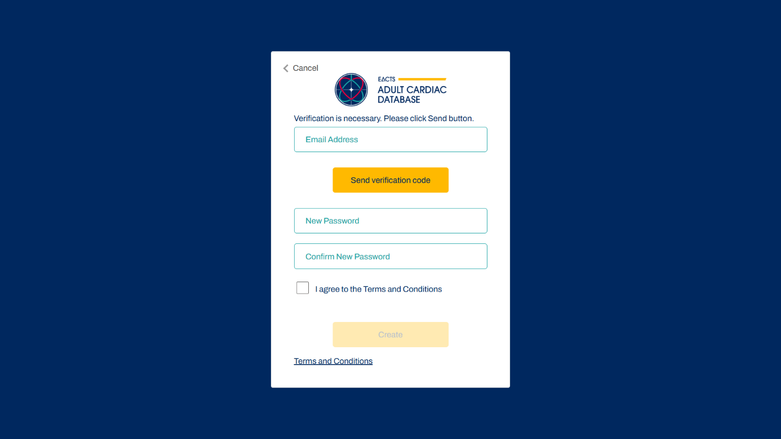
Selecting Option (a) above, will take you to the Sign Up page below:
Verify your email address and ensure you pick a secure password. Passwords can be up to 16 characters long and must contain a Lower or Upper case, numeric and special characters.

Click Create to complete the process
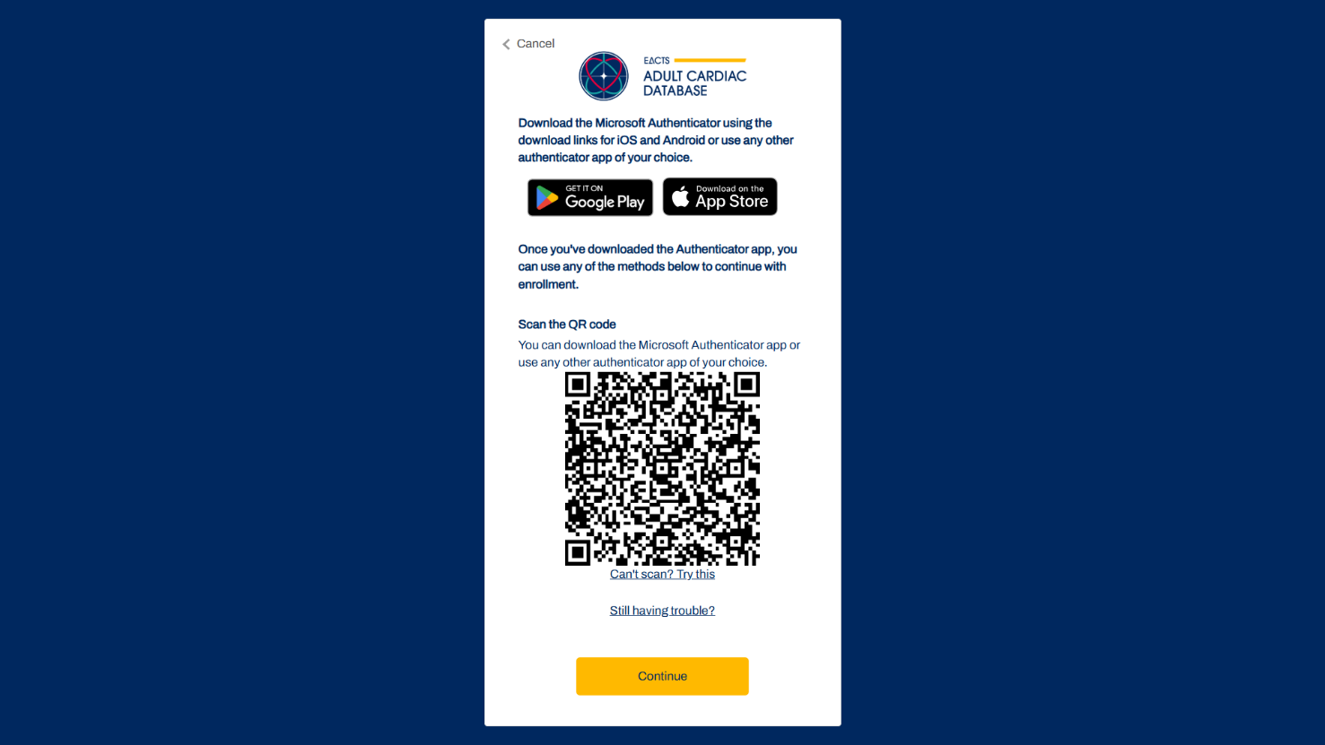
Scan the QR code through Microsoft Authenticator App which can be installed from the App Store or Google Play.
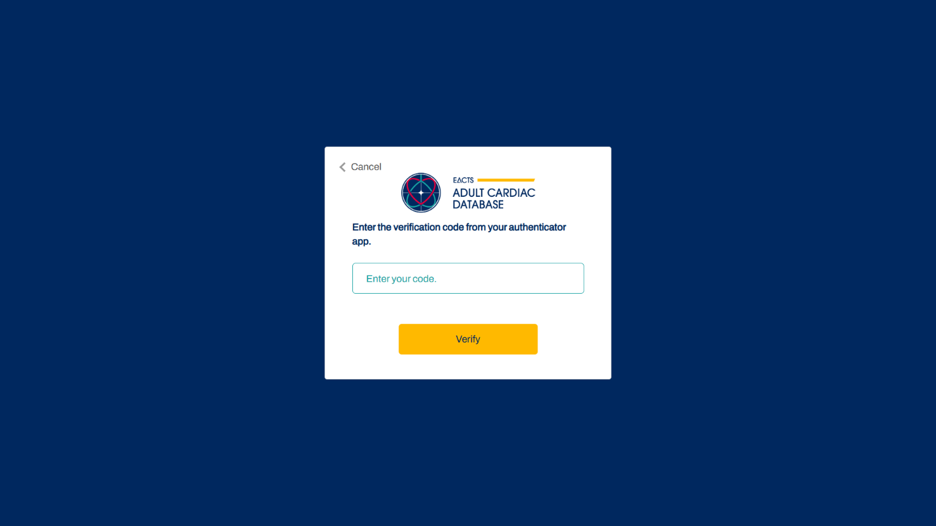
After pressing continue, enter the verification code from your authenticator app:
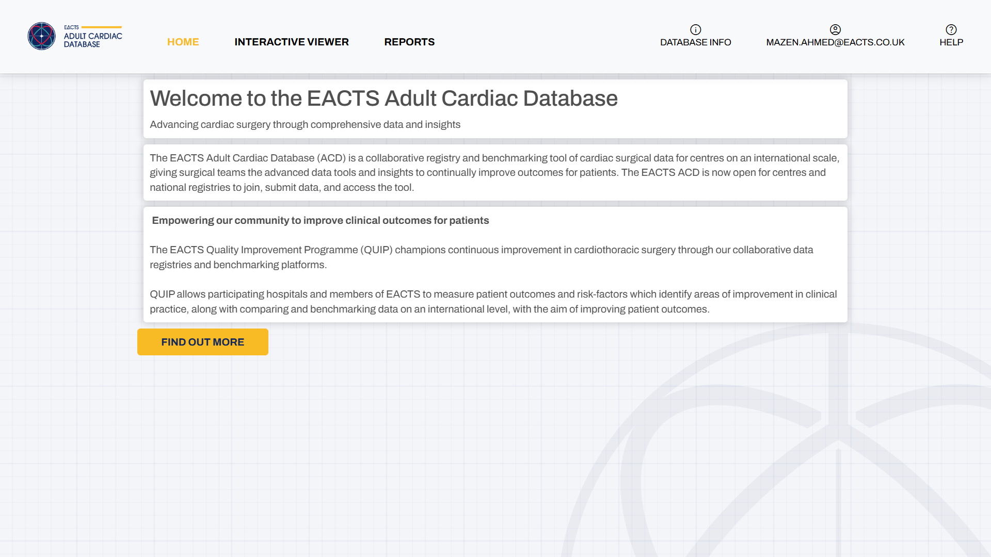
Once you have signed up an account you will gain access to the INTERACTIVE VIEWER and REPORTS tabs

Users that belong to a participating hospital should see HOSPITAL INFO:
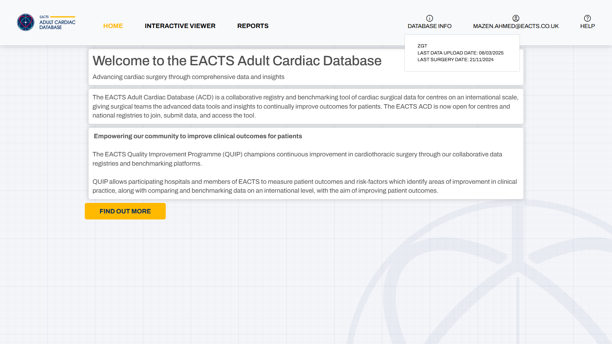
Selecting HOSPITAL INFO will give:
- Your hospital name
- Last

Selecting this will display:
- Your hospital name
- Last data upload date for your hospital
- Last surgery date for your hospital

If you find that this information is not correct, please log a support request here

Logging in using you Microsoft Work account (b)

If you have a Microsoft Work account and your IT administration can set-up the appropriate access, you can take option (b) below to access the ACD

a) Users can Sign-up an account by selecting Sign Up Now
b) For users that have a Microsoft Work Account you can login via Work Account

Users signing in via their Work Account for the first time may receive the following message:
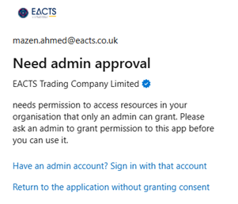

Your hospital’s IT administrator will need to provide you access to the platform.

Granting User Access using a Microsoft work account
The following section is applicable to Hospital IT administrators authorised to register applications themselves.

- Login to https://acd.eacts.org/ using an administrator account and accept the requested permission:
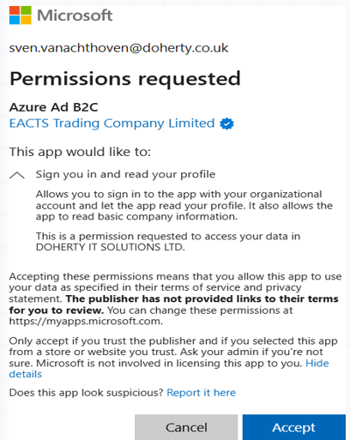

- The Administrator should then approve the Enterprise Application for all other users within their tenant:
  - Navigate to the Azure Portal, Entra ID and finally Enterprise Applications
  - Search for “Azure AD B2C” and select the entry with an Application ID of:
    - c7c52815-5b0c-4597-986a-7c7f6db2cb24
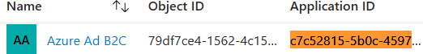

  - Navigate to Permissions
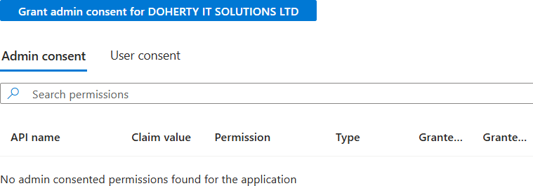

  - Select Grant admin consent for the Microsoft 365 tenant name to allow access for all future users.

Appendix 3 of the ACD Founding Charter outlines the ACD’s technical and security specifications
For help please contact quip@eacts.co.uk

