EACTS European Registry for Patients with Mechanical Circulatory Support (EUROMACS)
DATA ACCESS REQUEST PROTOCOL

- INTRODUCTION
  - This Protocol details the processes to be followed by the European Association for Cardio-Thoracic Surgery (“EACTS”) in response to specific Data Access Requests from the European Registry for Patients with Mechanical Circulatory Support (EUROMACS).
  - This Protocol shall be reviewed annually to ensure it aligns with best practices, supports the principles of good governance, and continues to uphold the purposes of this protocol, outlined in Section 3.

- DEFINITIONS
  - In this Protocol the terms set out below shall have the following meanings:
    - “EACTS” shall mean the European Association for Cardio-Thoracic Surgery, a company limited by guarantee and incorporated in England and Wales under company number 07401765.
    - “Participant” shall mean one of the Surgery Centres whose registration to EUROMACS has been accepted by EACTS.
    - “Core Source Data” shall mean all pre-/peri and post-operative data relating to a durable MCS procedure, including Personal Data relating to the associated patient and surgeon data.
    - “Data Extract” shall mean a duplicated extraction of the EUROMACS data.

    - “Data Access Request” shall mean a request for a Data Extract from EUROMACS.
    - “EACTS DA” shall mean the EACTS Data Administrator – an employee of EACTS with responsibility for managing the data included in the EUROMACS.
    - “EUROMACS” shall mean the European Registry for Patients with Mechanical Circulatory Support
    - “EUROMACS Committee” shall mean the sub-committee of EACTS members with responsibility for overseeing the management of EUROMACS.
    - “EUROMACS Data” shall mean the aggregated and anonymised pre-/peri- and post- operative data of (durable) MCS procedures in Europe submitted by the Participants and collectively held in EUROMACS. The Participants will submit EUROMACS Data in the form of an anonymised extract from the Core Source Data or by direct entry in the web-based interface, with all identifying markers or Personal Data relating to patients, medical practitioners, or other individuals involved in an operation, removed prior to delivery to EACTS.
    - “EUROMACS Data Dictionary” shall mean the standardised reference guide containing detailed information about the data within the Database.
    - “EUROMACS Hospital Sharing Agreement” shall mean the signed Agreement between EACTS and the EUROMACS Participants, which outlines the purpose, the principles, the sharing agreements and general governing rules for EUROMACS.
    - “Output” shall mean all intermediate and final results of EUROMACS Data once the Research has been completed. These include, but are not limited to, (scientific) papers/articles, (scientific) abstracts, reports, and social media posts.
    - “Requestor” shall mean the party submitting the Data Access Request. Requestor categories are specified in Appendix 1.
    - “Research” shall mean the intended processing and statistical analysis on the Data Extract data to investigate the research hypothesis laid out in the Data Access Request, resulting in the Output.
    - ‘Publication' shall mean the dissemination of the Output to any individual or entity external to the Requestor's organisation(s). This includes but is not limited to: (scientific) journals, conferences, third parties and social media.
    - “QUIP Director” shall mean the Director of the Quality Improvement Programme (QUIP) of EACTS.
    - “GDPR” shall mean the UK General Data Protection Regulation and the EU General Data Protection Regulation (and any successor legislation).
    - "Personal Data” shall have the meaning giving to it in GDPR.
    - “QUIP Committee” shall mean the Quality Improvement Programme (QUIP) Committee of EACTS with responsibility for the oversight of all databases deployed by EACTS.
    - “Scientific Lead” shall mean the lead scientific officer engaged on behalf of EACTS and reporting to the QUIP Director.
    - “Scientific Panel” shall mean the committee of individuals involved in methodological assessment of the Data Access Request or Output.

- PURPOSE OF THE PROTOCOL
  - The Protocol has been put in place to:
    - Ensure that the data is used for public benefit, safely, and in compliance with legal regulations.
    - Ensure consistency in the handling of external or internal requests for data to be extracted from EUROMACS.
    - Implement governance for the management of data access requests from EACTS members, Participants, third parties, or internally generated within EACTS itself, to ensure that EACTS team members are protected from the risks of improper data access requests.
    - Confirm the approach to charging for data extracts.
    - Reassure the EUROMACS Participants that the data that has been submitted is handled with care and propriety.
  - EACTS recognises the Five Safes Framework as best practice in managing data extracts for research purposes and is working to align to this standard.

- DATA QUERY PRINCIPLES
  - Data Queries shall be performed against the anonymised EACTS EUROMACS Data.
  - EUROMACS is managed by the EACTS QUIP Committee and EUROMACS Committee with the terms of the EUROMACS Hospital Sharing Agreement. A copy of the EUROMACS Charter is available upon request.
  - Information on the specific data fields and their definitions provided in EUROMACS are available via a standard specification and reference guide called the EUROMACS Data Dictionary. The Data Dictionary is available on the EACTS website or upon request.
  - All data within EUROMACS is anonymised at both patient and surgeon level. It is not possible to provide any query output that identifies any individual patient or surgeon.
    - Any Data Access Request that attempts to identify any Relevant Individual, or any Personal Data, for example by referencing a specific and exceptional combination of procedures, will be rejected.
  - All Data Extracts are anonymised on centre; preventing Requestors to link particular procedures to individual centres.
    - In the event that the Research conducted by the Requestors necessitates the use of center-identifying information, explicit approval shall be sought from the respective individual centers.
  - Any Data Extract shall be compliant with the GDPR regulations.
    - Legal basis for EUROMACS is based on informed consent

- DATA ACCESS REQUEST
  - Data Access Requests may be submitted by EACTS-members, Participants, non- EACTS members, and Industry Representatives. Different terms, conditions, and fees may apply for different types of Requestors.
  - Data Access Requests may result in Outputs intended for Publication or Outputs not intended for Publication.
  - Data Access Requests must be submitted by completing a Data Access Request Form to the EACTS DA.
  - In accordance with the Five Safes Framework, EACTS Scientific Lead, QUIP Director and EUROMACS Committee Chair maintain the authority to evaluate the Requestor’s capacity to conduct the Research.
    - Should the Requestor fail to demonstrate sufficient capacity, the Data Access Request may be denied.
  - The procedures for submitting Data Access Requests, whether intended for Publication or not intended for Publication, are set forth in Appendix 2.
    - Should the Requestor, upon receiving a Data Extract through the 'not intended for Publication' procedure, subsequently determine that the Output should be published, the 'intended for Publication' procedure shall be followed.
  - For Data Access Requests in which the Output is intended for Publication, the Scientific Lead, advised by the Scientific Panel, will confirm the scientific validity of the proposed research; where that scientific validity cannot be sufficiently demonstrated, the EACTS Scientific Lead can veto the Data Access Request.
  - In all Data Access Requests, final approval to proceed will be provided by the QUIP Director and EUROMACS Committee Chair, advised by the EUROMACS Committee.
    - In the event the Output is intended for Publication, consultation with the Committee is mandatory. If the Output is not intended for Publication, obtaining the Committee's advice shall be at the discretion of the QUIP Director and the Chair.
    - In the case that the EUROMACS Committee is formally consulted each member can cast 1 (one) vote and approval is given by a majority vote, however consensus is preferred. Votes not submitted within the pre-defined (typically 2 [two] weeks) timeframe shall not be considered.
    - In case of a tie in the voting process EUROMACS Committee Chair is authorized to cast 2 (two) votes to reach majority vote.
  - The data extract parameters will be approved by the EACTS Scientific Lead. The data extract itself will be subject to peer review by the EACTS Scientific Lead or their appointed deputy.
  - The data extract will be sent to the requestor by the QUIP Director or their appointed deputy via a Secure File Transfer system.
  - Upon receiving the Data Extract the Requestor will adhere to the terms and conditions specified in the Data Access Request Form and this Data Protocol document.
  - Upon receiving the Data Extract, Requestor shall store the data securely and ensure diligent handling of the data in compliance with the EU GDPR.

- OUTPUT AND PUBLICATION
  - Any Output intended for Publication must include acknowledgement of EUROMACS Committee.
    - Acknowledgement of individual participants may be requested by the EUROMACS Committee.
  - In case of Publication, the Output(s) will be subject for peer-review by the Scientific Lead, consulted by the Scientific Panel, on the scientific validity of the Output.
  - The Scientific Lead, with counsel from the Scientific Panel, shall verify:
      - The Output's alignment with the research plan as outlined in the Data Access Request Form.
      - The absence of any major methodological errors in the Product.
  - In case of violation of section 6.3.1.1; the EUROMACS Committee Chair has the authority to suspend Publication.
    - Requestors may submit an amendment to their Data Access Request, explicitly detailing the new Research to be conducted within the scope of the original Data Access Request. Any Publications resulting from these amendments must designate the additional Research as 'Post-Hoc' within the Output. Amendments follow the same procedure as Data Access Requests intended for Publication.
  - In case of Publication of the Output; Requestors will not share the Data Extract without explicit permission from EUROMACS Committee Chair and QUIP Director.

- RESEARCH TIMEFRAME
  - Requestors will have 6 (six) months after the Data Access Request research end-date to carry out the Research specified in the Data Access Request if the intention is a Publication.
    - EACTS shall not grant Data Access Requests intended for Publication on “Similar Research” within this timeframe.
    - Requestors may waive this Research Timeframe in case of Outputs not intended for Publication.
      - Allocating a Data Access Request as ‘Similar Research’ is at the discretion of the EUROMACS Committee Chair and QUIP Director, advised by the Scientific Lead, and potential consultation of EUROMACS Committee and Scientific Panel.
    - Upon receiving the Data Extract, Requestor shall store the data securely and ensure diligent handling of the data in compliance with the EU GDPR. Researchers shall delete the Data Extract when the Research is completed.

- DATA ACCES REQUEST FEES
  - No fees shall apply for Requestors in the category “EACTS-members” and “Participants”. (Appendix 1)
  - Fees shall apply for Requestors in the category “Non-EACTS members” and “Industry representatives”. (Appendix 1)
    - Fees for Data Access Requests shall be established on a case-by-case basis, taking into account the Requestor's organisation, the number of datapoints
requested, and the nature of the intended Research.
      - The Fee Structure for Data Access Requests shall be established by the QUIP Committee and the EUROMACS Committee, in consultation with the QUIP Director, Scientific Lead and EACTS Chief Executive. The Fees will be made available to the Requestor after the request has been made.

APPENDIX 1 – REQUESTOR CATEGORY

Category | Description
Participant | One of the Surgery Centres whose registration to EUROMACS has been accepted by EACTS.
EACTS member | An EACTS member, registered in the EACTS membership system, not being designated an Industry Member. This includes EACTS paid personnel.
Non-EACTS member | Not a paying EACTS member, but a medical professional or researcher employed by a non- profit organisation.
Industry Representative | Individual representing a for-profit organisation.

APPENDIX 2 – PROCESS FOR RESPONDING TO A DATA ACCES REQUEST
Figure 1 - Process for responding to a Data Access Request not intended for Publication
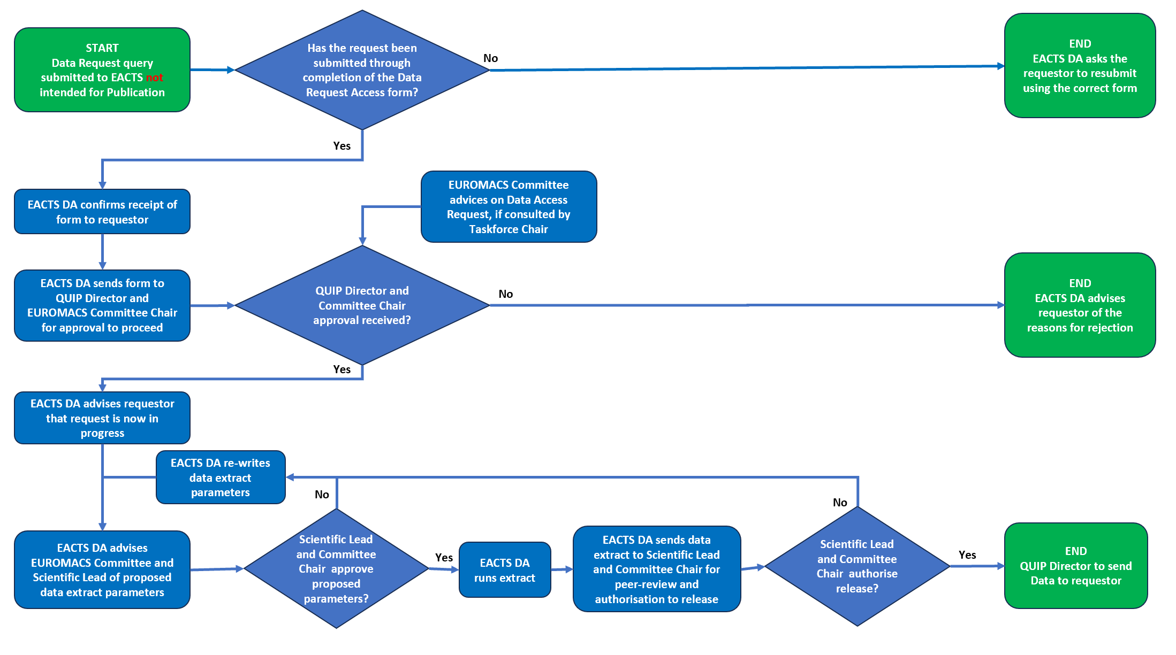

QUIP ADULT CARDIAC DATABASE DATA PROTOCOL VERSION 1.1, 09 -01 -2025

www.eacts.org 8

Figure 2 - Process for responding to a Data Access Request intended for Publication
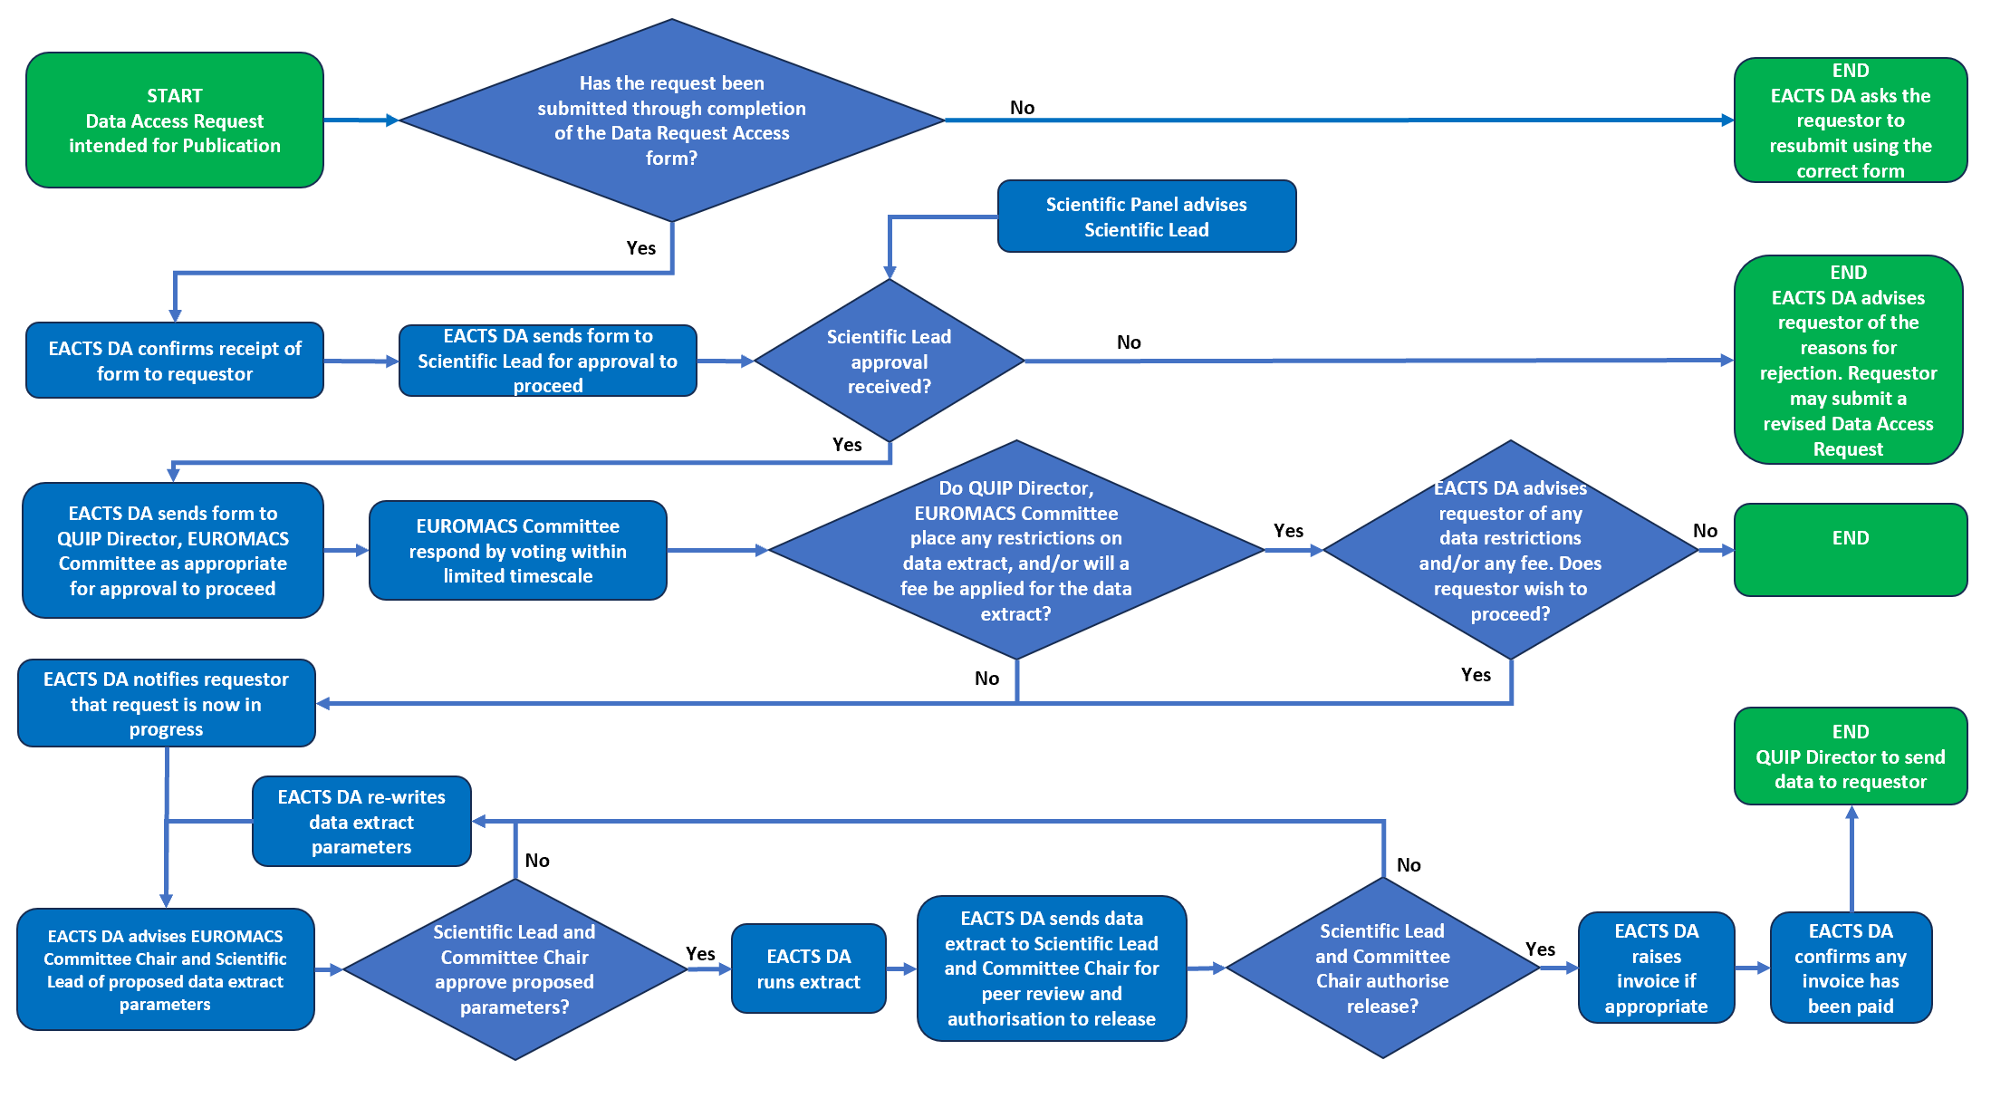

QUIP ADULT CARDIAC DATABASE DATA PROTOCOL VERSION 1. 1, 09-01 -2024

www.eacts.org 9

